Edge Server

🌐 What is an Edge Server?
# Source: Chatgpt (GPT-5-Mini) at [1/16/2026]
An Edge Server is a server located physically closer to the end user or device, designed to process data, cache content, or run applications at the “edge” of a network — rather than relying on a central data center.
🚀 Its main goal is to reduce latency and improve performance by handling data or requests closer to where they originate.

🧠 Why Is It Called "Edge"?
# Source: Chatgpt (GPT-5-Mini) at [1/16/2026]
Because it's deployed at the "edge" of the network — near users or devices — instead of deep inside the core infrastructure.

🔧 What Does an Edge Server Do?
# Source: Chatgpt (GPT-5-Mini) at [1/16/2026]
Function | Example Use
⚡ Caching content | Stores website assets (images, videos) locally
🧠 Pre-processing data | Filters or analyzes data before sending to cloud
🕸️ IoT Gateway | Connects and manages nearby IoT devices
📡 Content delivery | Speeds up video streaming or file downloads
🧩 App container runtime | Runs parts of an app close to the user

🌍 Where Is an Edge Server Used?
# Source: Chatgpt (GPT-5-Mini) at [1/16/2026]
Industry | Use Case Example
📺 Streaming | Netflix uses edge servers to reduce buffering
🚗 Automotive | Cars send sensor data to nearby edge servers
🏭 Manufacturing | Machines send status to on-site edge nodes
🏙️ Smart Cities | Traffic sensors talk to local edge systems
🧠 AI & ML | Real-time decisions on edge (e.g., surveillance)

🆚 Edge Server vs Central Server
# Source: Chatgpt (GPT-5-Mini) at [1/16/2026]
Feature | Edge Server | Central Server
📍 Location | Near user or device | In data center or cloud
⚡ Speed | Low latency, faster response | Higher latency
📶 Network Use | Sends less data to the cloud | Sends all raw data to the cloud
🧠 Processing | Local, real-time decisions | Heavy processing and storage
🔌 Dependence | Can work offline or semi-connected | Needs internet connection

🧭 Examples of Edge Servers in Action
# Source: Chatgpt (GPT-5-Mini) at [1/16/2026]
- CDNs (Content Delivery Networks): Cloudflare, Akamai, or AWS CloudFront place edge servers worldwide to serve web pages faster.
- Retail: Cameras in stores send video to edge servers to detect shoplifting in real-time.
- Healthcare: Wearable devices transmit vitals to edge servers in hospitals for immediate alerts.

✅ Summary
# Source: Chatgpt (GPT-5-Mini) at [1/16/2026]
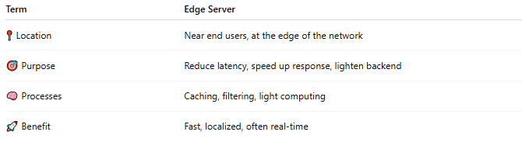

Term | Edge Server
📍 Location | Near end users, at the edge of the network
🎯 Purpose | Reduce latency, speed up response, lighten backend
🧠 Processes | Caching, filtering, light computing
🚀 Benefit | Fast, localized, often real-time

Would you like:
- 🔗 A diagram showing how edge servers fit into a network?
- ☁️ To compare Edge Computing vs Cloud Computing?
- 📦 To see how Edge Servers are used in CDNs like Cloudflare?

